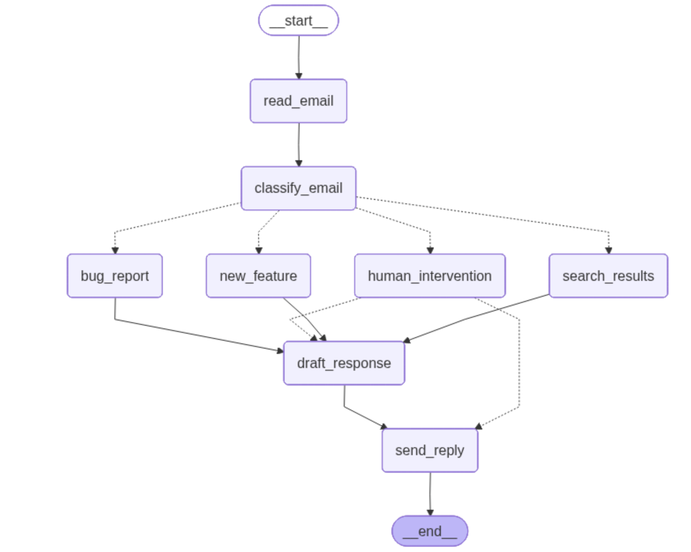

Test Results

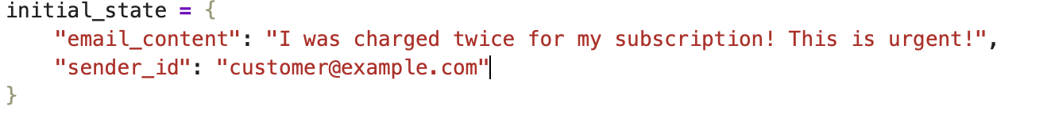
Test Case 1 :
Approval needed and custom response to be sent since not approved
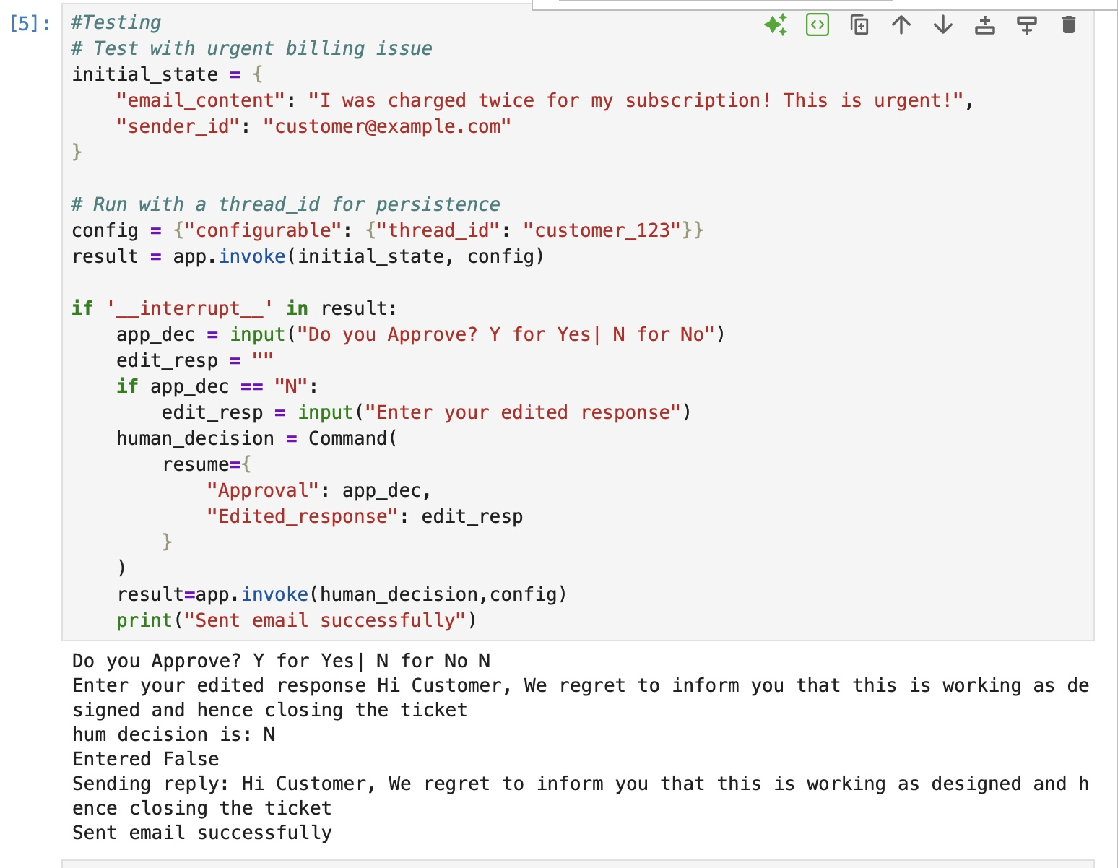

Test Case 2:
Approval needed. Approved. So model generates the email
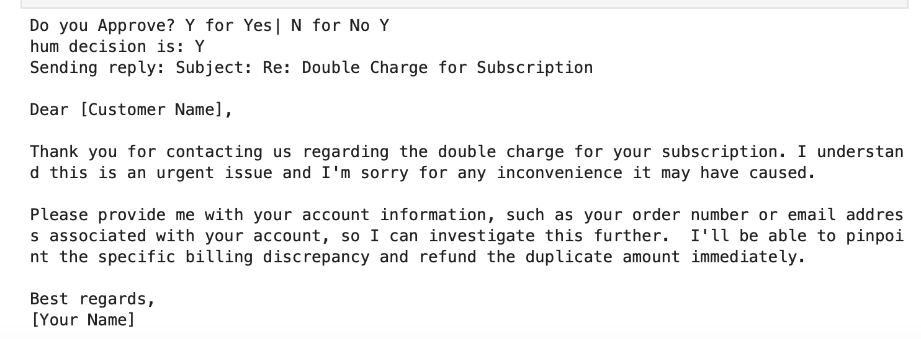

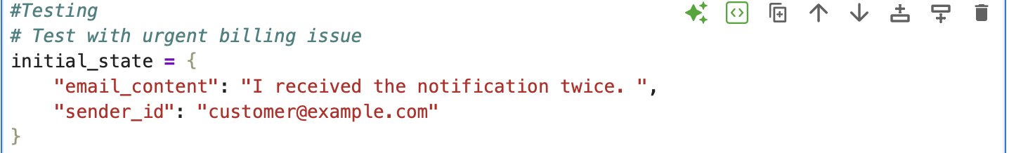
Test case 3 :
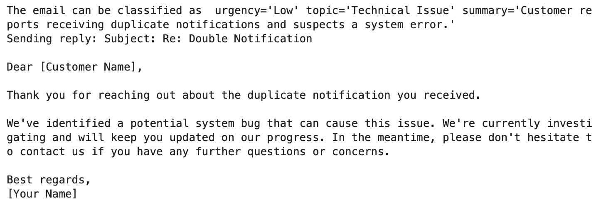
Result

